**MINI PROJECT**

**PROJECT TITLE: ART GALLERY MANAGEMENT**

**ER DIAGRAM:**

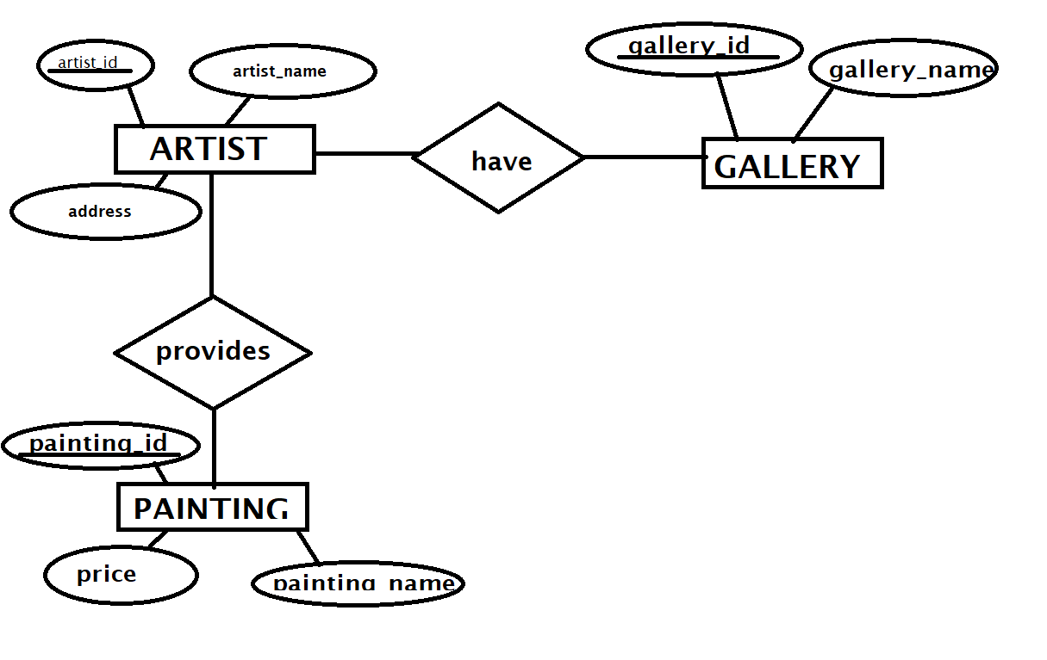

**CONVERT ENTITY RELATIONSHIP DIAGRAM TO RELATIONS**

**1)ARTIST:**

|  |  |  |  |  |
| --- | --- | --- | --- | --- |
| **artist_id** | **artist_name** | **address** | **gallery_id** | **painting_id** |

**2)GALLERY**

|  |  |  |
| --- | --- | --- |
| **gallery_id** | **gallery_name** | **artist_id** |

**3)PAINTING;**

|  |  |  |  |
| --- | --- | --- | --- |
| **painting_id** | **painting_name** | **price** | **artist_is** |

**RELATIONS WITH DATA**

**1)ARTIST**

|  |  |  |  |  |
| --- | --- | --- | --- | --- |
| **artist_id** | **artist_name** | **address** | **gallery_id** | **painting_id** |
| **1** | **Ram** | **Panaji** | **103** | **618** |
| **2** | **Sham** | **Mapusa** | **102** | **601** |
| **3** | **Omkar** | **Ponda** | **101** | **627** |

**2)GALLERY**

|  |  |  |
| --- | --- | --- |
| **gallery_id** | **gallery_name** | **artist_id** |
| **101** | **The Space of Creativity** | **3** |
| **102** | **Art Gallery by Sham** | **2** |
| **103** | **The Art Tech** | **1** |

**3)PAINTING**

|  |  |  |  |
| --- | --- | --- | --- |
| **painting_id** | **painting_name** | **price** | **artist_is** |
| **601** | **Portrait** | **1500** | **2** |
| **627** | **Landscape** | **1000** | **3** |
| **618** | **Still Life** | **2000** | **1** |

**LIST ALL SQL QUERIES IMPLEMENTED USING FRONT END:**

**Insert data into ARTIST table**

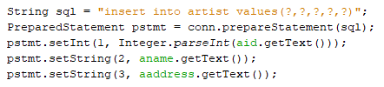

**Insert data into GALLERY table**

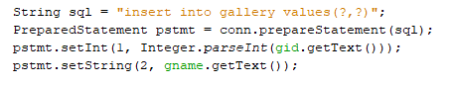

**Insert data into PAINTING table**

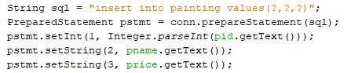

**Searching data into ARTIST table**

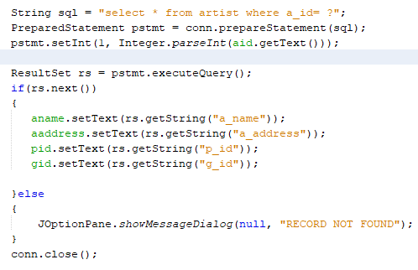

**Searching data into GALLERY table**

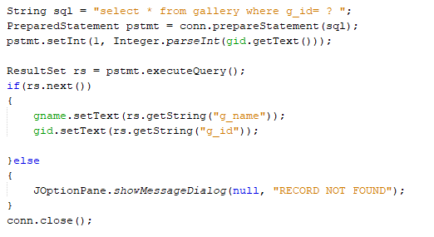

**Searching data into PAINTING table**

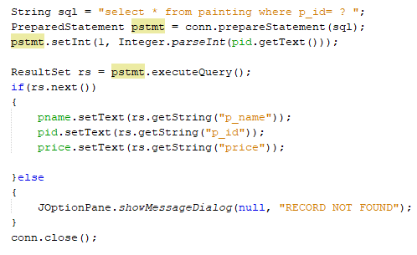

**Updating data in ARTIST table**

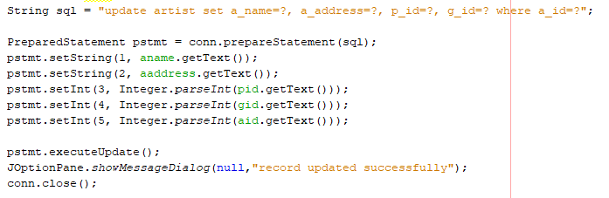

**Updating data in GALLERY table**

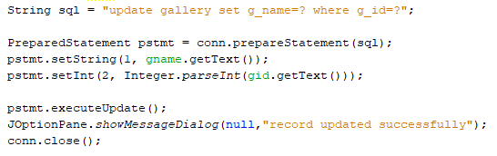

**Updating data in PAINTING table**

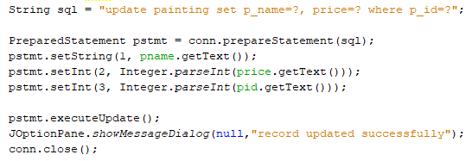

**Deleting data in ARTIST table**

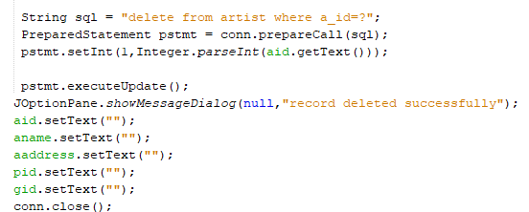

**Deleting data in GALLERY table**

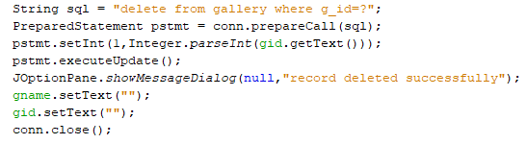

**Deleting data in PAINTING table**

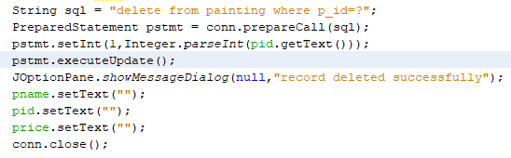

**Displaying data from ARTIST table**

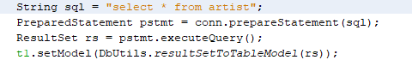

**Displaying data from GALLERY table**

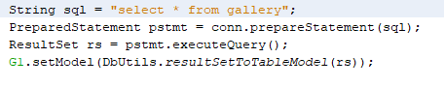

**Displaying data from PAINTING table**

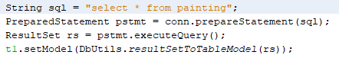

Displaying data of ARTIST table(using Subqueries)

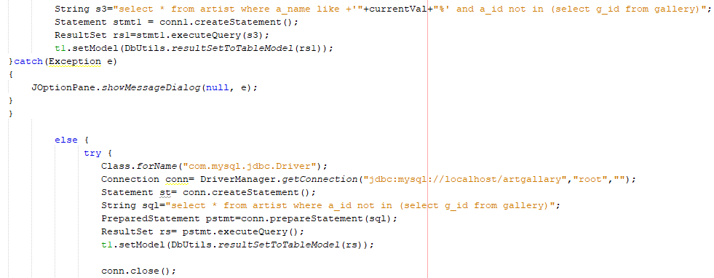

Displaying data of ARTIST and PAINTING table(using Join operation)

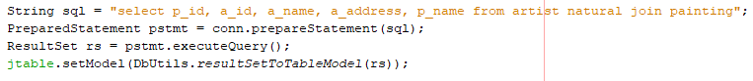

Displaying data of ARTIST and GALLERY table(using Join operation)



Displaying sum price of painting from PAINTING table(using Aggregate )

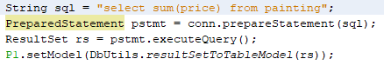

Displaying minimum price of painting from PAINTING table(using Aggregate )

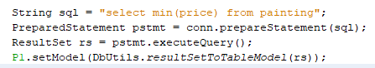

Displaying average price of painting from PAINTING table(using Aggregate )

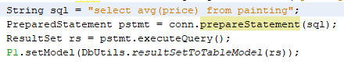

Displaying count price of painting from PAINTING table(using Aggregate )

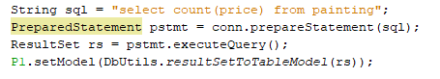

Displaying maximum price of painting from PAINTING table(using Aggregate )

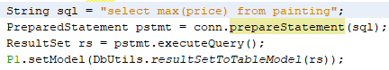

Displaying details of ARTIST and GALLERY table(using views)

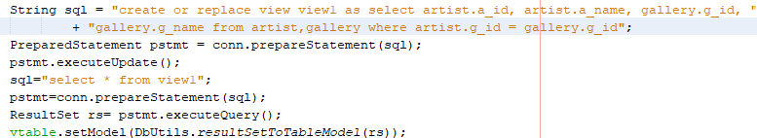

**Displaying main Page of ART GALLERY MANAGEMENT**

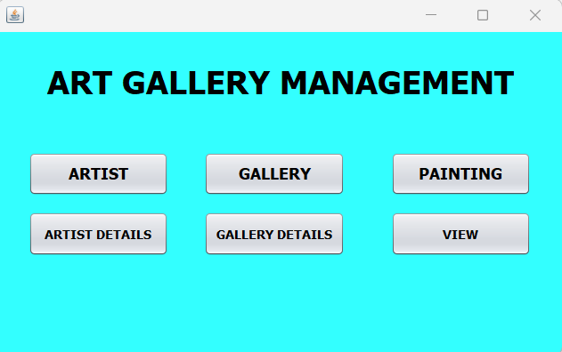

**Displaying home main of ARTIST table**

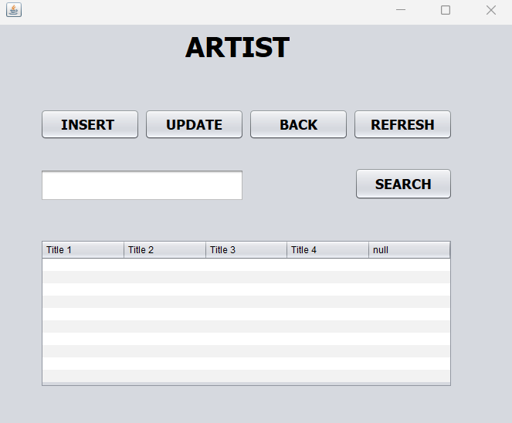

Displaying home main of GALLERY table

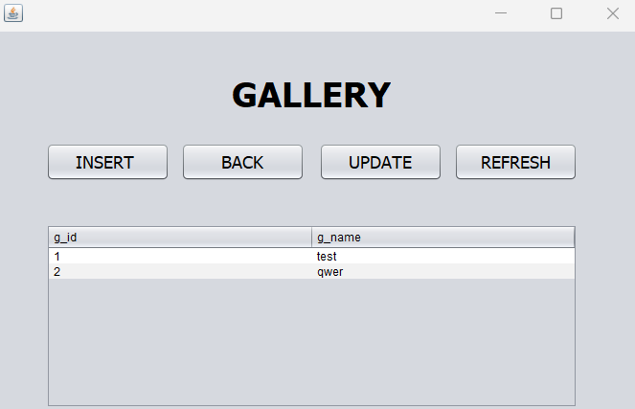

Displaying home main of PAINTING table

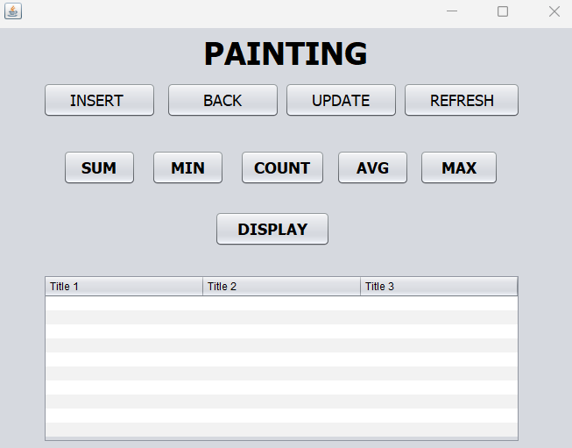

Inserting data in ARTIST table

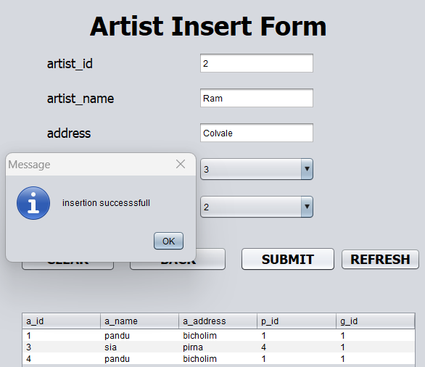 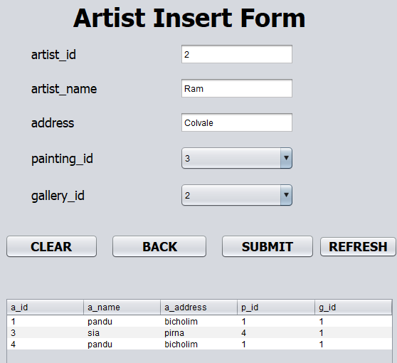

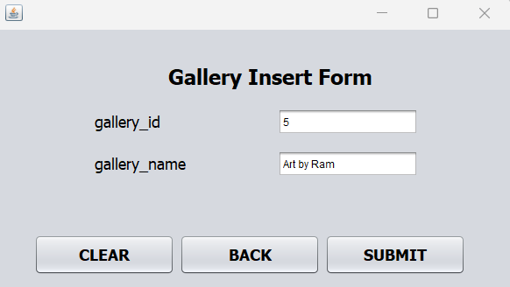Inserting data in GALLERY table

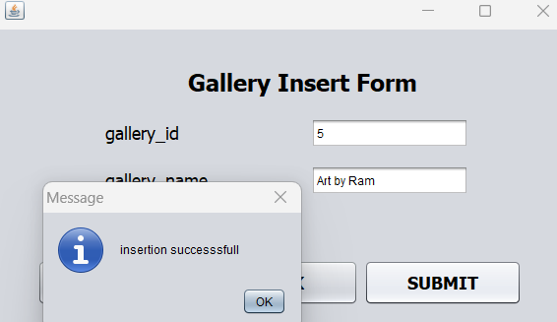

Inserting data in PAINTING table

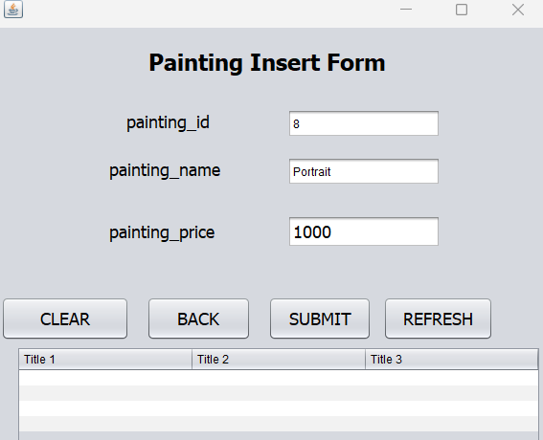 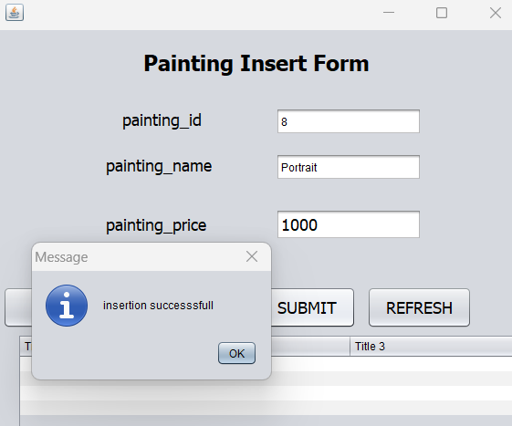

Searching data in ARTIST table

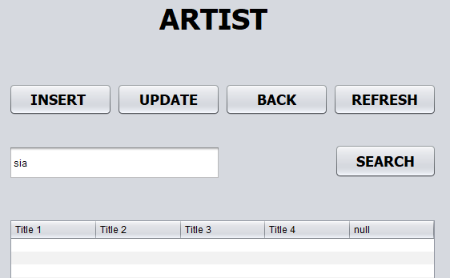 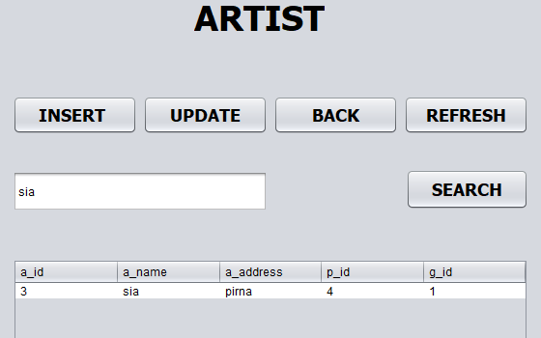

Searching data in GALLERY table

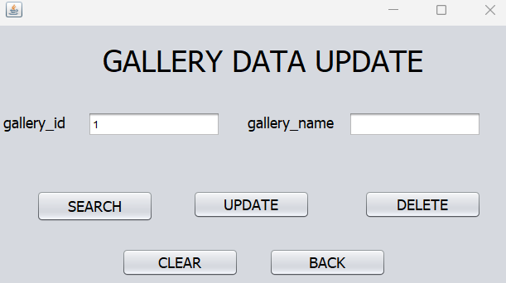 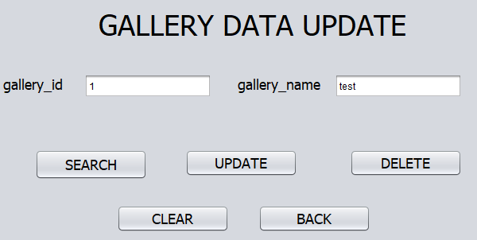

Searching data in PAINTING table

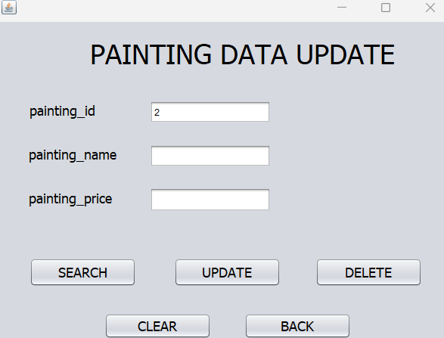 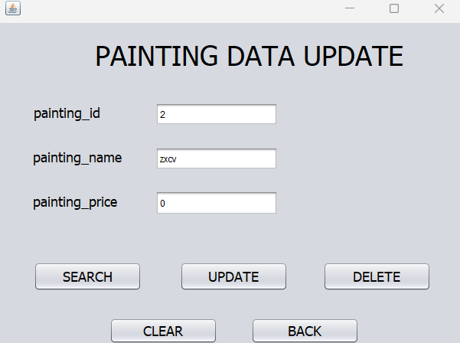

Updating data in ARTIST table

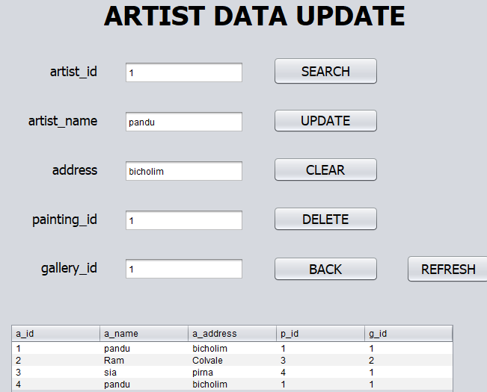 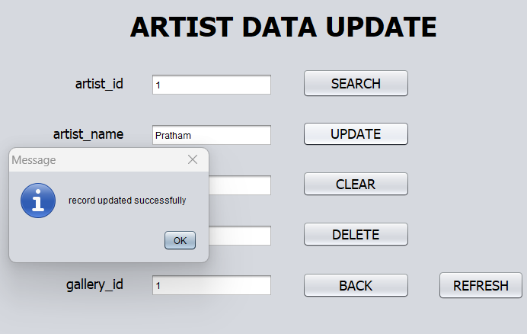

Updating data in GALLERY table

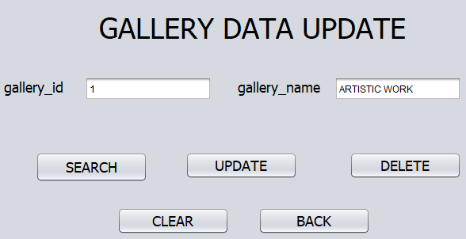 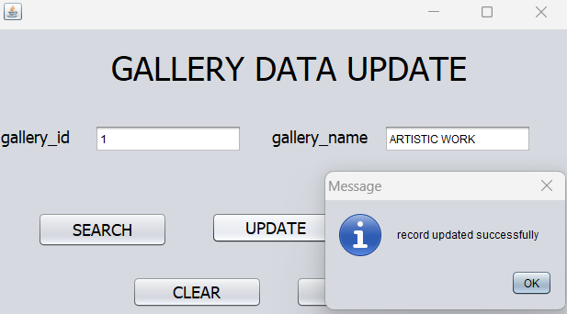

Updating data in PAINTING table

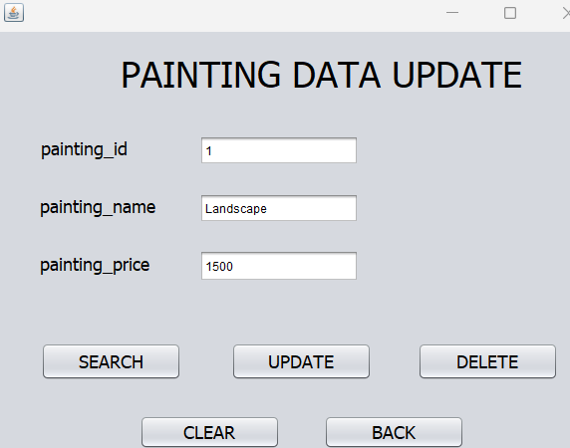 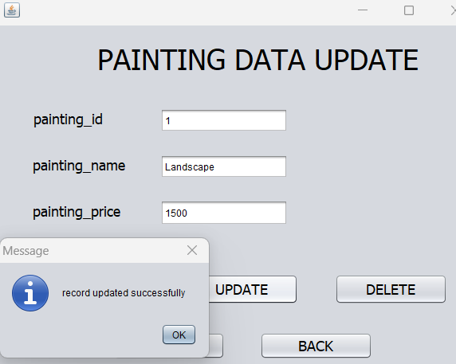

Deleting data in ARTIST table

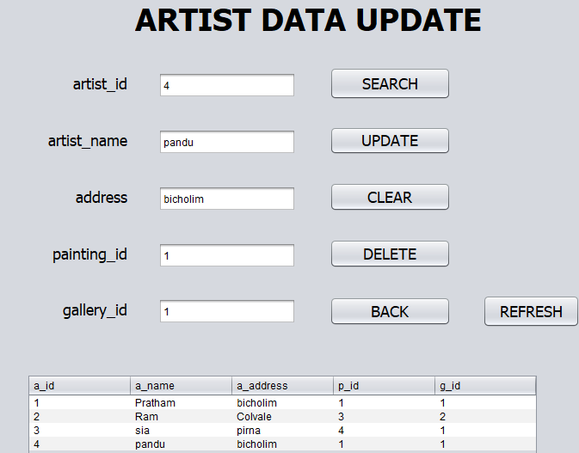 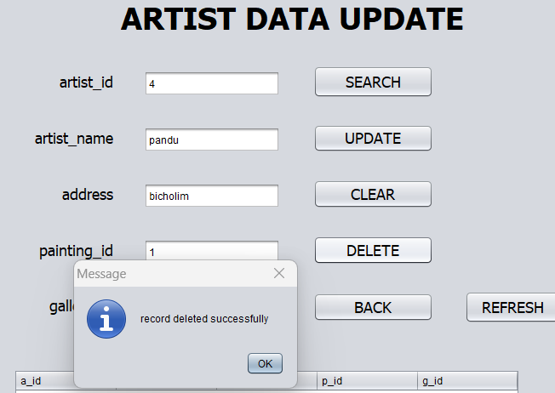

Deleting data in GALLERY table

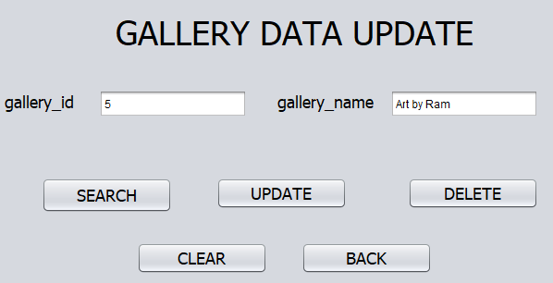 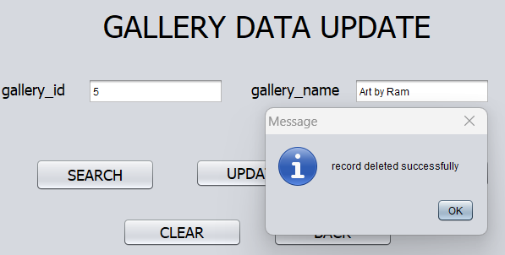

Deleting data in PAINTING table

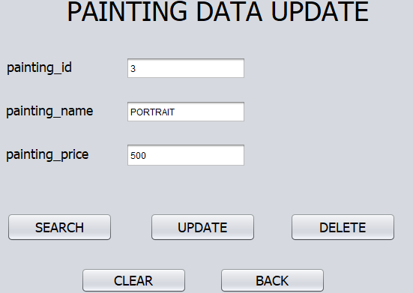 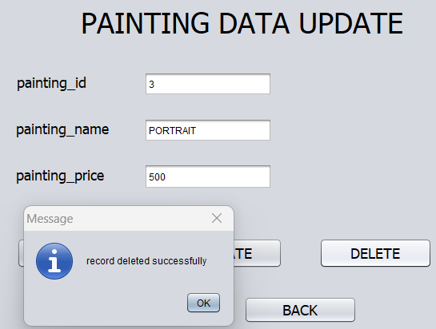

Displaying data in ARTIST table

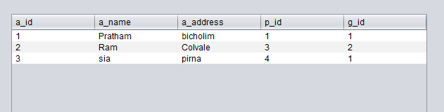

Displaying data in GALLERY table

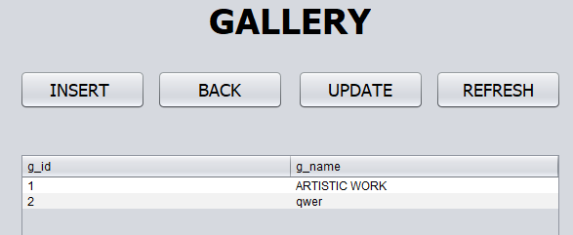

Displaying data in PAINTING table

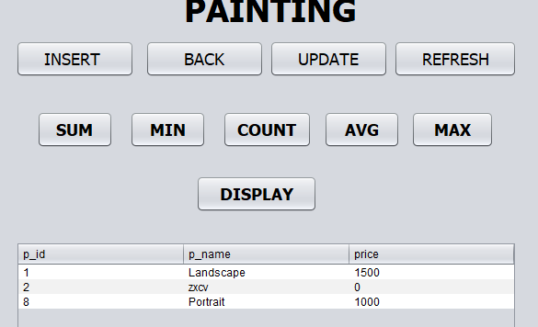

Displaying data of ARTIST table(using Subqueries)

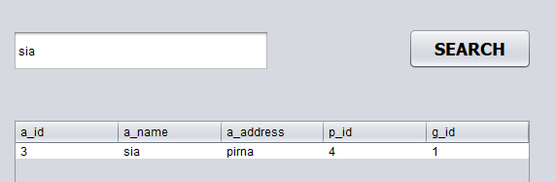

Displaying data of ARTIST and PAINTING table(using Join operation)

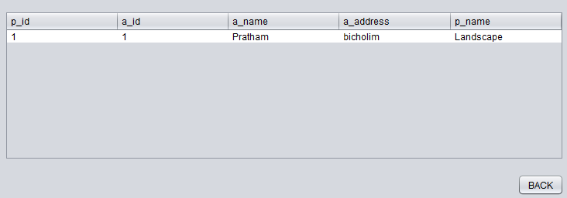

Displaying data of ARTIST and GALLERY table(using Join operation)

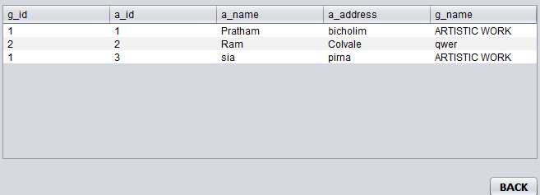

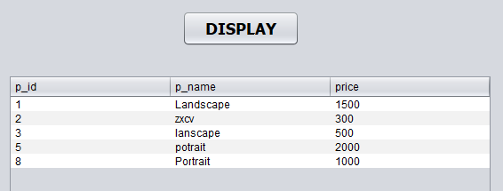

Displaying minimum price of painting from PAINTING table(using Aggregate )

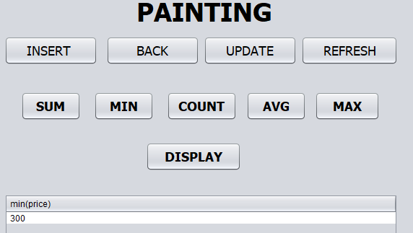

Displaying maximum price of painting from PAINTING table(using Aggregate )

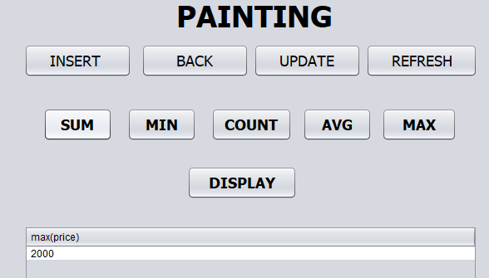

Displaying sum price of painting from PAINTING table(using Aggregate )

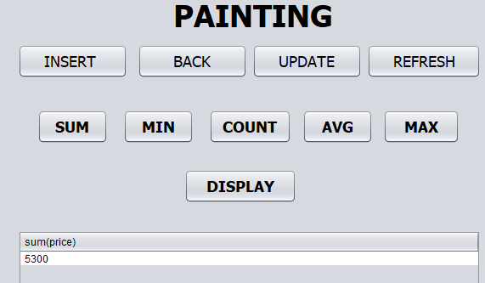

Displaying average price of painting from PAINTING table(using Aggregate )

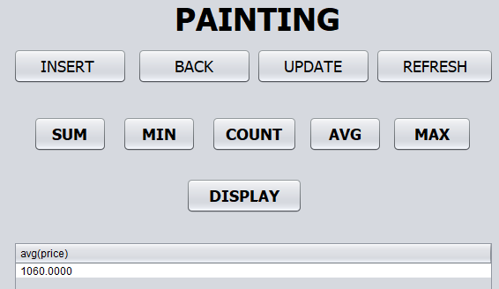

Displaying count price of painting from PAINTING table(using Aggregate )

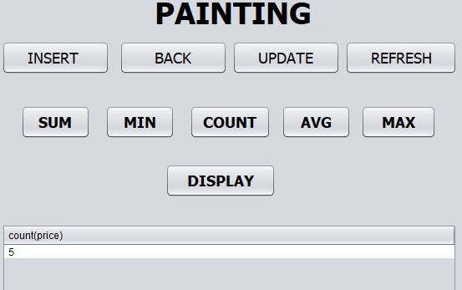

Displaying details of ARTIST and GALLERY table(using views)

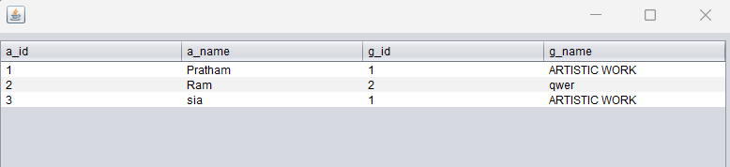

**CONCLUSION:**

In the mini project, we learnt to represent the given problem statement into an entity relationship diagram along with cardinality and participation constraints. Then, conversion of the ER diagram to Relation which were further implemented in the database. The graphical user interface and database connection was implemented using which the data from the database could be accessed n modified. The data manipulation in the database was successfully implemented using SQL queries.